Using LIDAR and High-resolution Remote Sensor Data for Topographic Mapping in a Coastal Marsh Area
Xiaojun Yang
Department of Geography, Florida State University, Tallahassee, FL32306, USA; email: xyang@fsu.edu

Abstract
This article reports a preliminary research effort that aims to investigate the utility of LIDAR (Light Detection and Ranging) and high-resolution remote sensor data for topographic mapping with part of the North Inlet bay in Georgetown, South Carolina, USA as a case. The study site is largely below 1 meter above the sea level and consists of salt marshes behind barrier islands and numerous tidal creeks. The LIDAR data were collected in January 2003 and the entire data set was processed by using vegetation removal algorithms to create a bare-earth model. The nominal posting density ranges from 1.5 to 5 meters. A triangulated irregular networks (TIN) model was derived from the LIDAR data through the Delaunay triangulation. The TIN model was further converted into a grid-based surface model with 1-meter cell size. Then, accuracy assessment was conducted by using a random sample of 1024 points through a cross-validation method. The model was found to have a global RMSE of 0.05 meter, indicating very high vertical accuracy. Our ongoing work include hydrographic feature extraction from this grid-based digital terrain model by using GIS-based hydrological modeling technique and further validation using a high-resolution ADAR (Airborne Data Acquisition and Registration) image scene covering the same area that was acquired in October 2000.

1. Introduction
Because of the great environmental and ecological values, estuarine marshes have been a focus for numerous interdisciplinary efforts to discover patterns, relationships, and models that led to successful management and sustainable use of the resources (Hobbie 2000). However, these efforts may be hindered because of the lack of adequate topographical data over estuarine tidal areas (Populus et al. 2001). Most of the currently available digital elevation data sets, such as GTOPO30, USGS DEMs, and NASA SRTM, are basically useless for estuarine marsh areas where the terrain is featureless and of limited contrast. Thus, there is a strong need to develop high-resolution elevation data sets for these environmentally sensitive areas.
This article reports a research aiming to build a high-resolution digital terrain elevation model for part of the North Inlet estuary in Georgetown, South Carolina, USA (Figure1) by using airborne LIDAR (Light Detection and Ranging) data. This has been part of an interdisciplinary effort to investigate the relationship between stream order, water quality, and natural influences in the North Inlet estuary. High-resolution digital elevation data are needed for GIS-based hydrological network modeling to delineate hydrographical features and to determine stream orders. LIDAR technology has already demonstrated its capability in producing digital terrain models with sub-meter vertical and horizontal resolutions (Populus et al. 2001; Hodgson et al. 2003; and Lowe 2003). Therefore, LIDAR data should be well suited for estuarine marsh elevation mapping.

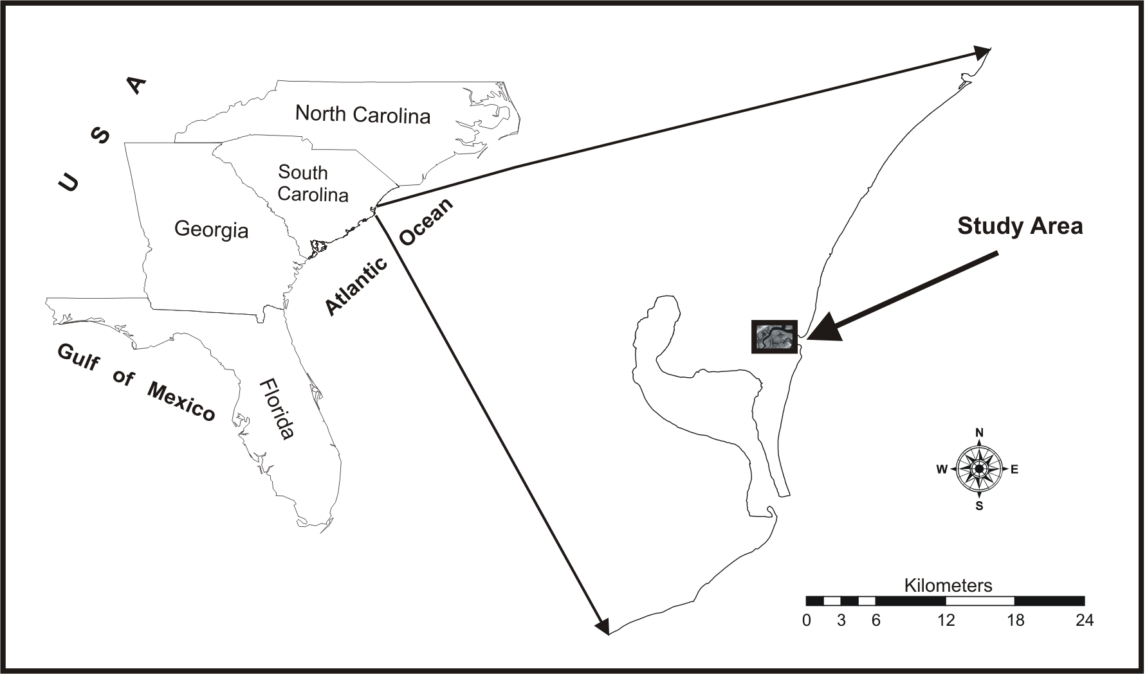
Figure 1. Location of the study area. It is located along the Atlantic coast of South Carolina, USA. The study site covers an area of 6.16 km²

2. Methodology
The study site is located along the Atlantic coast, covering an area of approximately 6 km². It mainly consists of salt marshes behind barrier islands, along with numerous tidal creeks (Figure 2). These creeks receive large volumes of ocean water that flow unto and out of the marsh twice daily (NOAA 2004). The terrain is underlain by a complex sequence of older coastal plain sediments. Most of the study area is below 3 feet above the sea level.

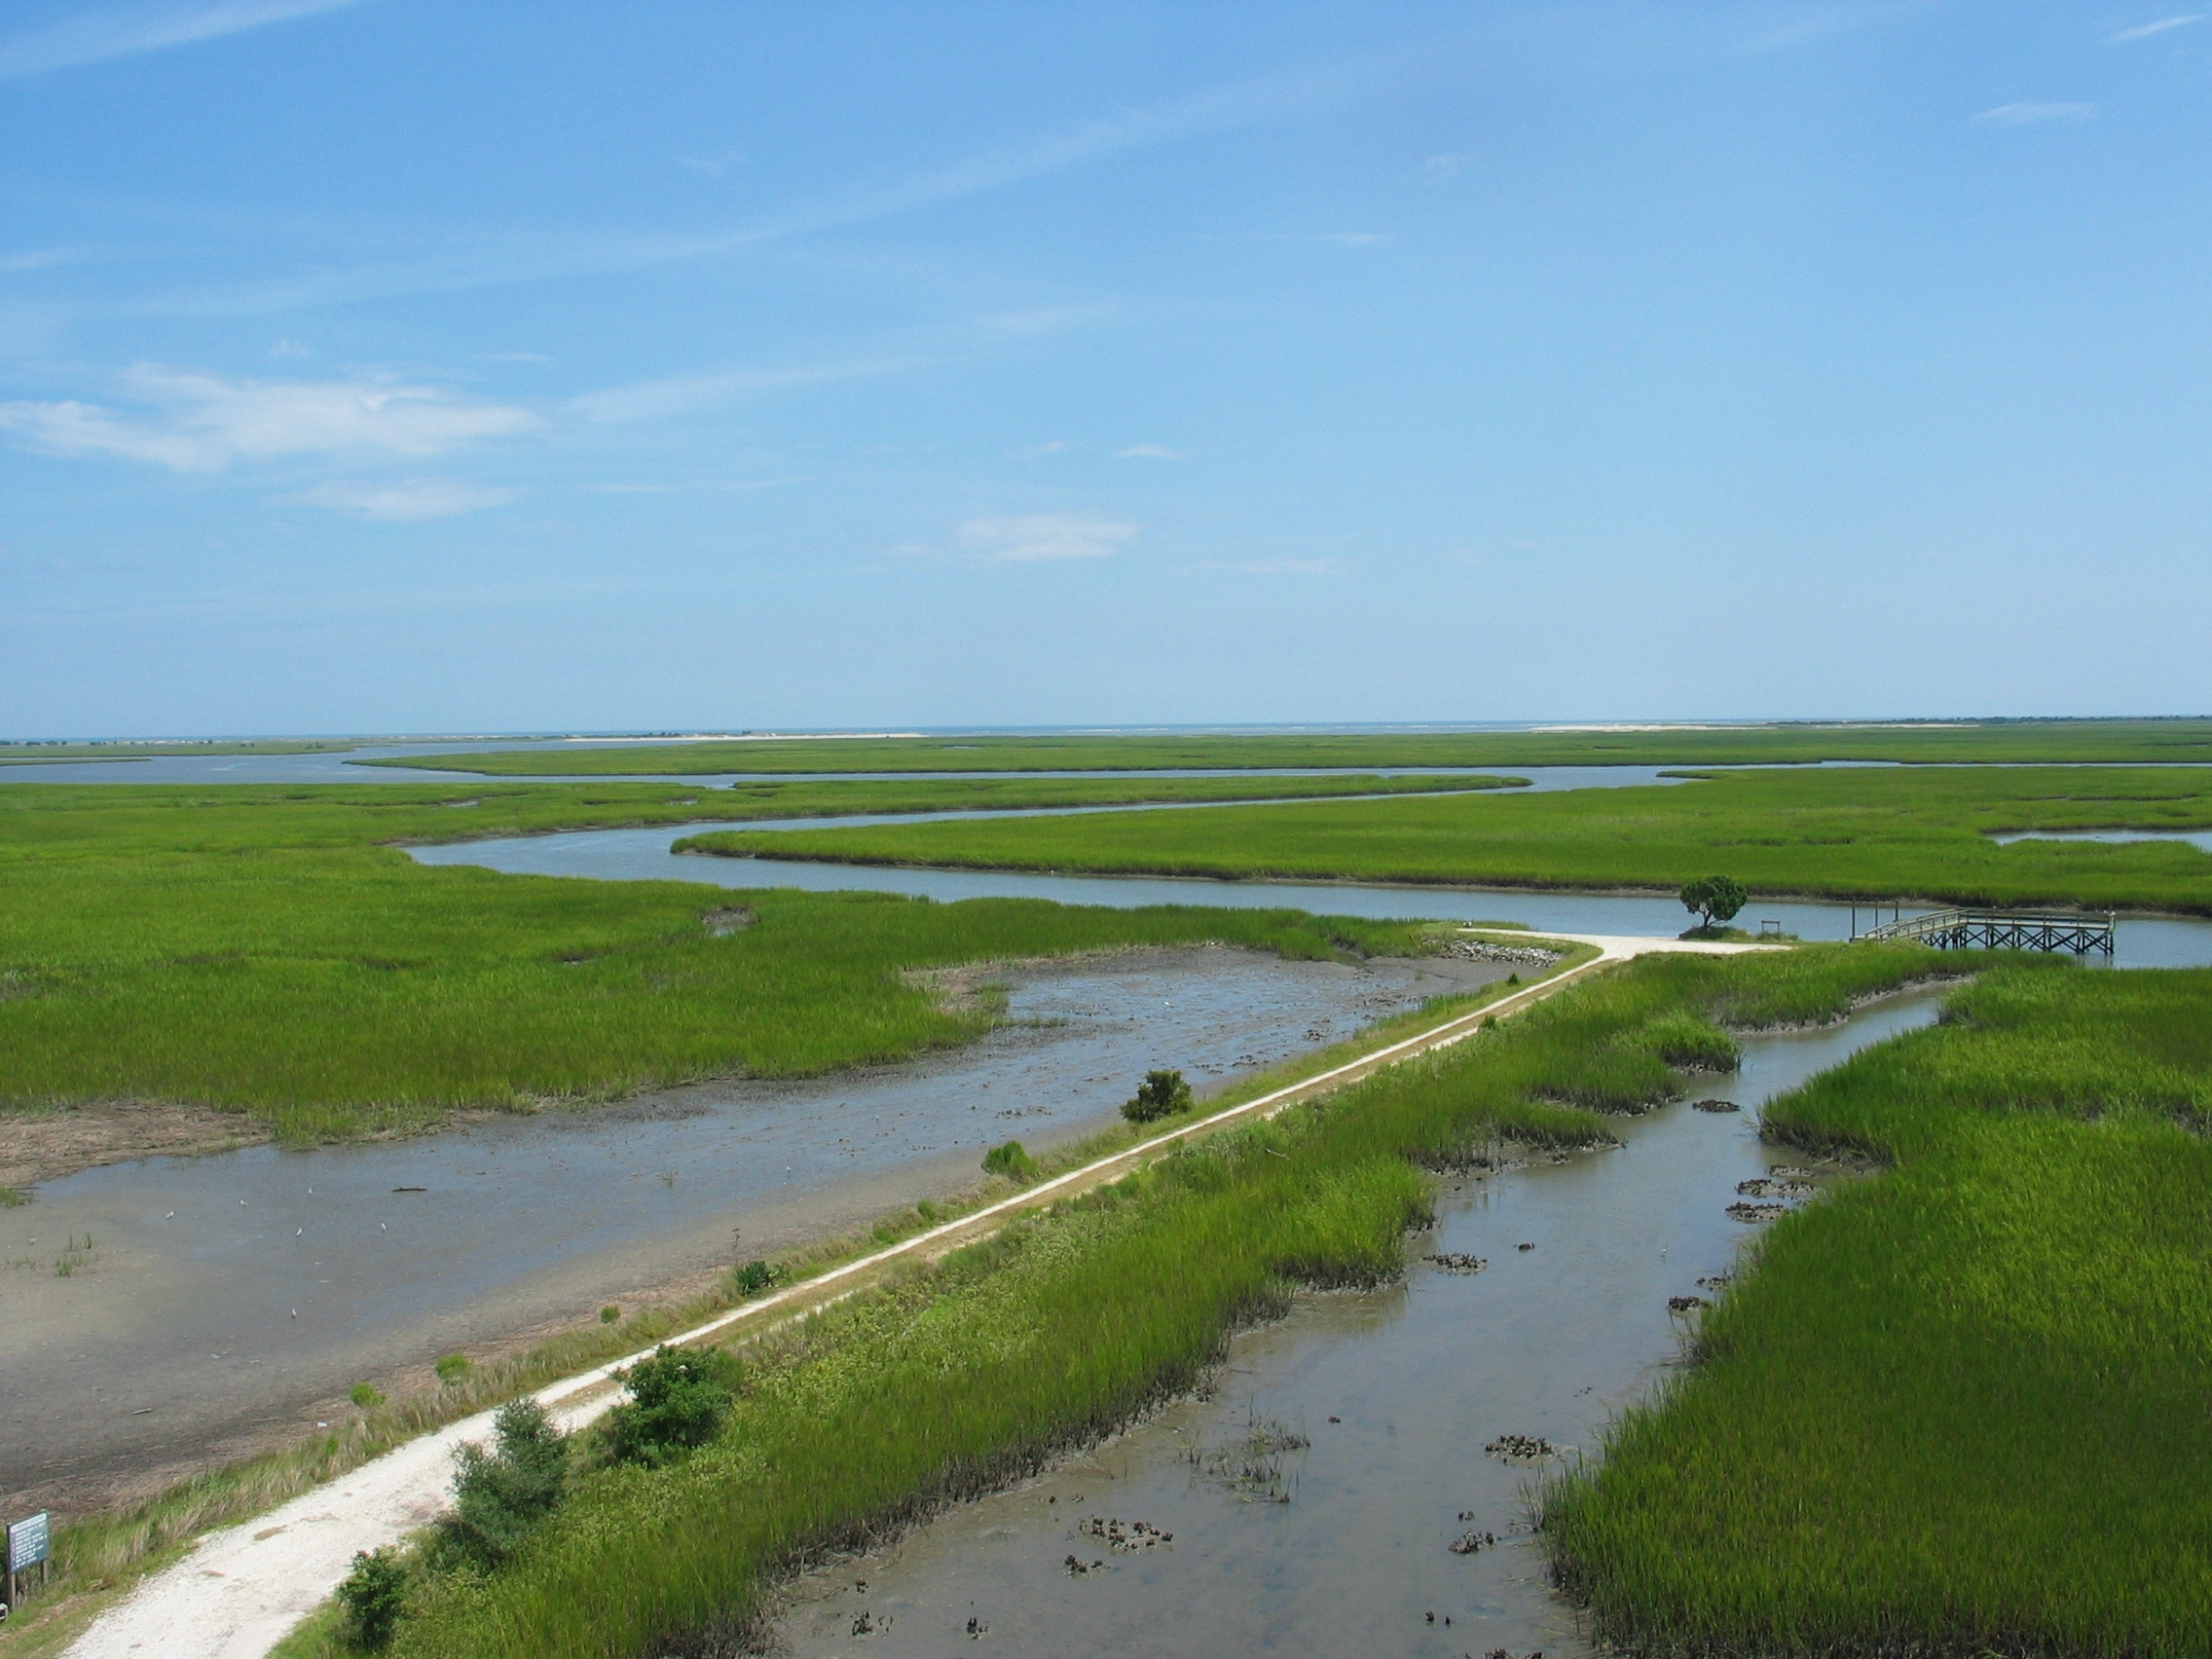
Figure 2. A photo showing part of the North Inlet estuary, Georgetown, South Carolina, USA. The site consists of a large area of salt marsh (in green) and numerous tidal creeks. The photo was taken on 13 August 2003 by Luoheng Han at the University of Alabama.

The LIDAR data were collected by Airborne1, Inc., using an Optech ALTM 2025 sensor on 16 January 2003 (Morris et al. 2005). The entire data set was processed by using vegetation removal algorithms to create a bare-earth model. The nominal posting density ranges from 1.5 to 5 meters. The LIDAR elevation data set contains a total of 1,247,819 points. Each point has a record of horizontal coordinates and elevation. The data set was organized in ASCII format. It has been georeferenced to the UTM map projection (Zone 17), WGS84 horizontal datum, and WGS84 ellipsoid.
A TIN (Triangulated Irregular Networks) model was created from the LIDAR elevation points by using the Delaunay triangulation method (Zeiler 1999). The TIN surface model consists of 2,495,221 irregular triangles, 1,247,653 nodes, and 7,485,663 edges, which demands a great deal of computational resources even for a 3-D drawing operation. To improve the computational speed, the TIN model was converted into a grid-based surface model with 1-meter cell size. Then, an accuracy assessment was conducted by using a random sample of 1,024 points through a cross-validation method. The model was found to have a global RMSE (Root Mean Square Error) of 0.164 foot. Figure 3 is a three-dimensional perspective view of this grid model with a vertical exaggeration of 25 times for better portraying the terrain relief.
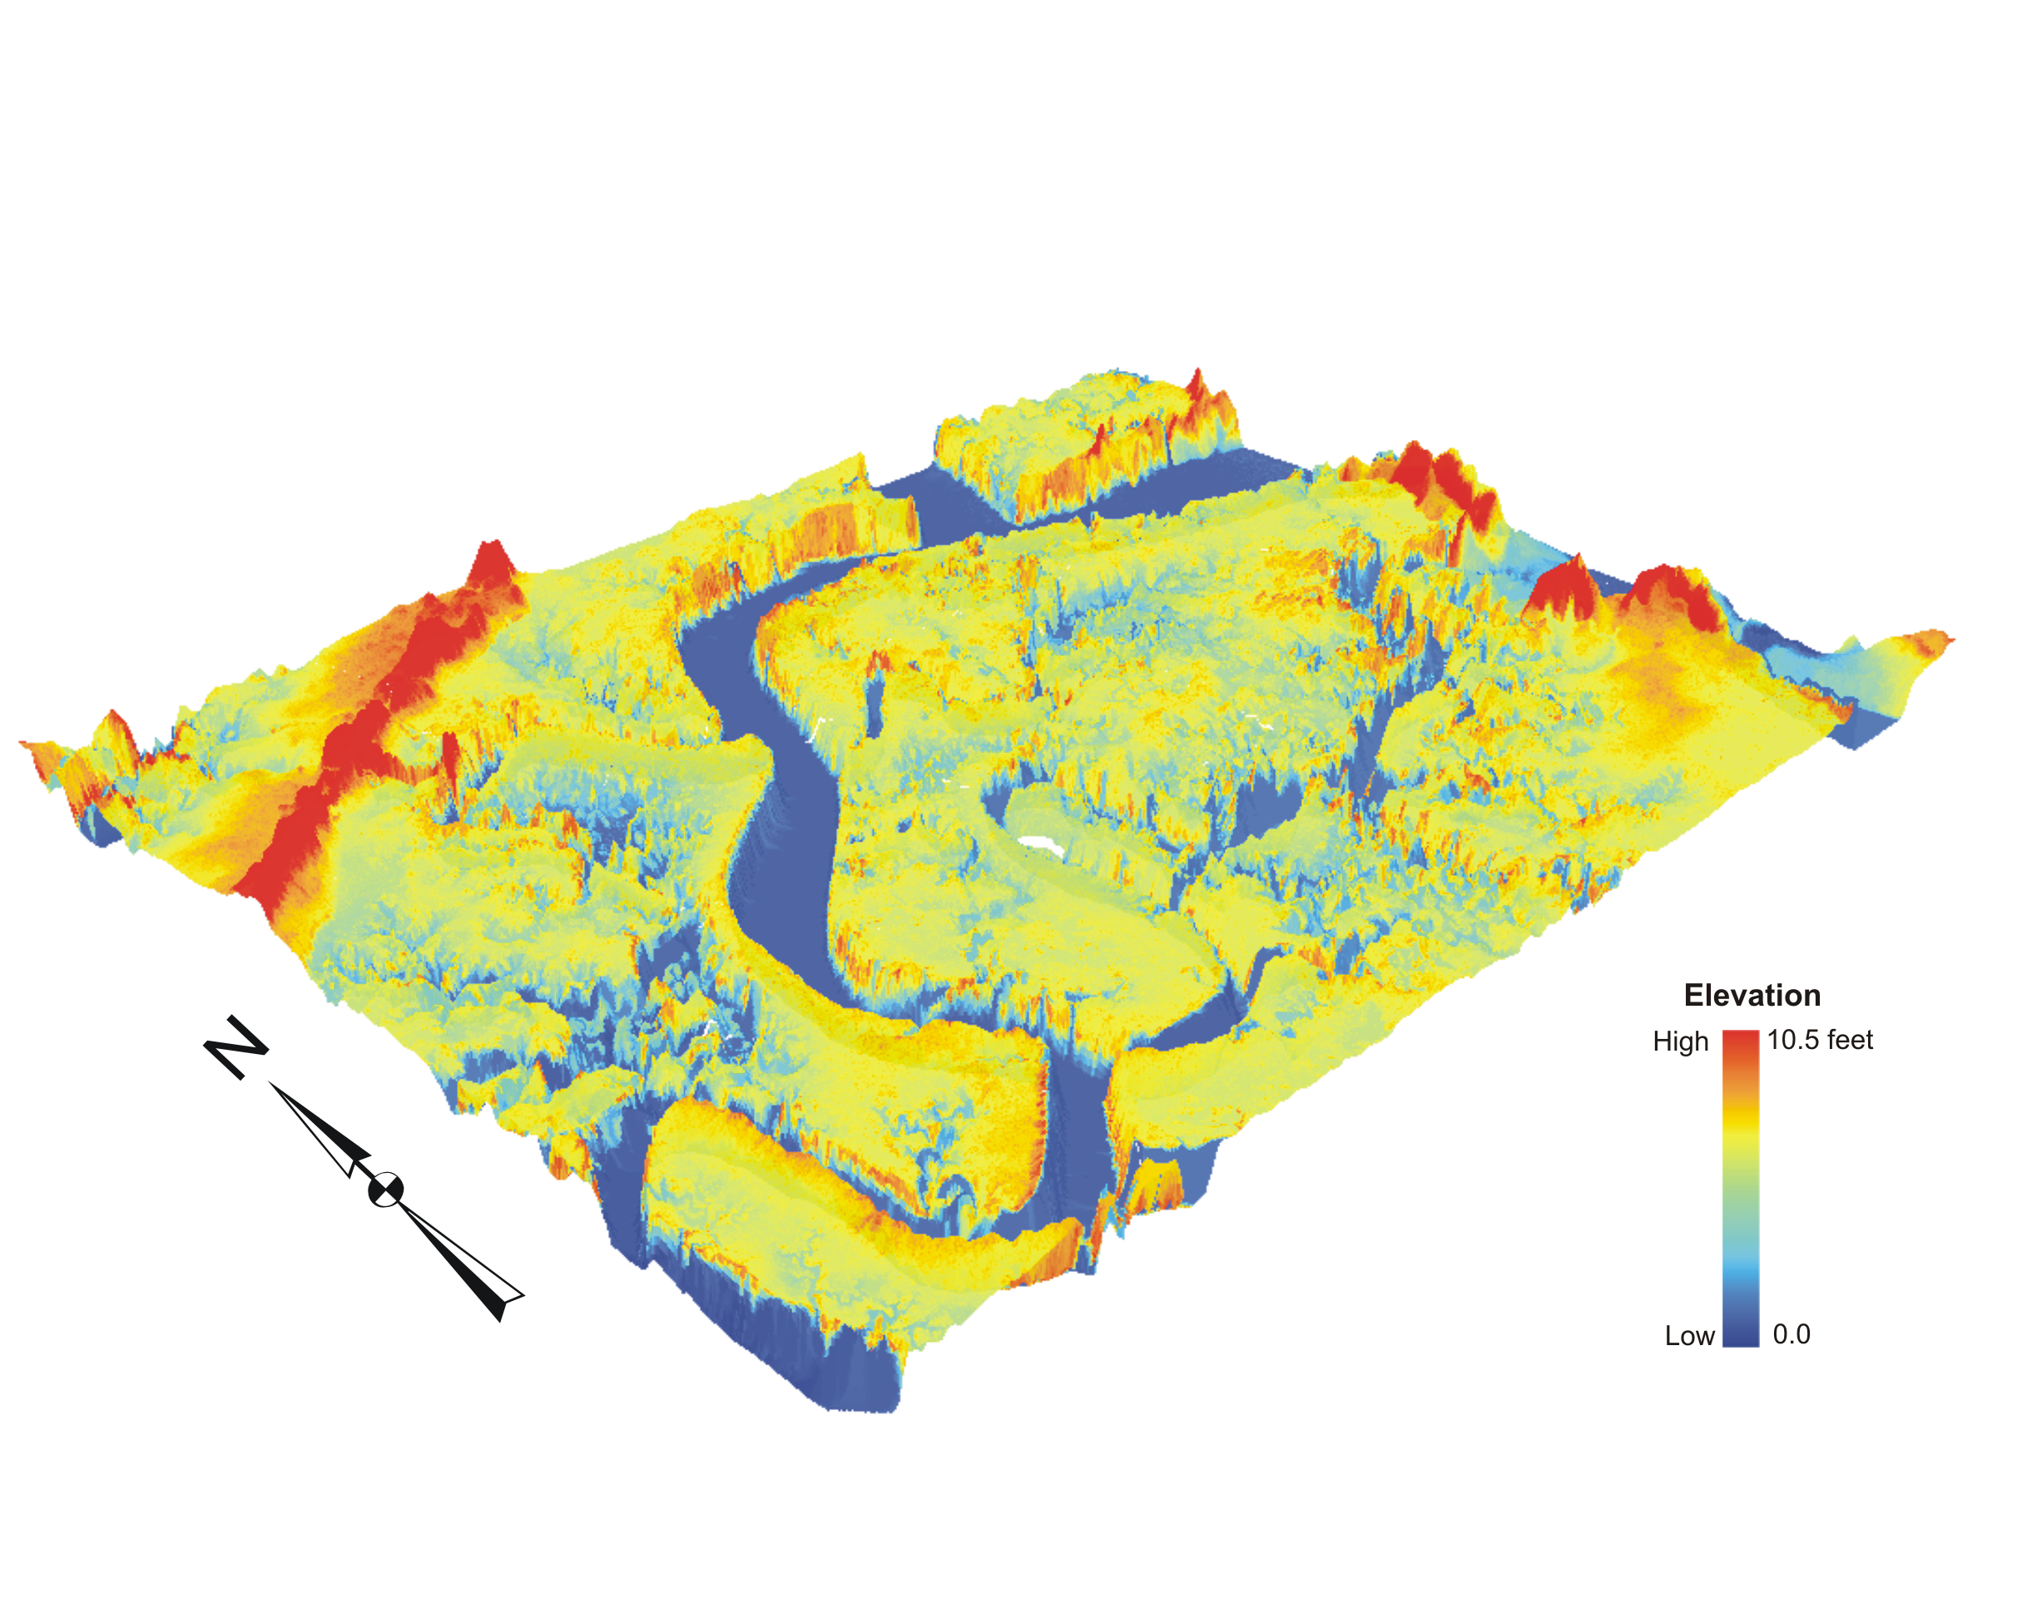
Figure 3. A three-dimensional perspective view of the digital terrain elevation model created by using Delaunay triangulation from LIDAR elevation data. The model covers a ground area of approximately 2180 m by 2760 m. Note that the vertical scale has been exaggerated for 25 times to better portrait the terrain relief.

A high-resolution multispectral image acquired by an ADAR (Airborne Data Acquisition and Registration) 5500 digital camera system in October 2000 (Morris et al. 2005 )was used for the validation of terrain features derived from the aforementioned digital elevation model. The ADAR image has a nominal spatial resolution of 0.7 meter, and consists of four bands, namely, blue (450-540 nm), green (520-605 nm), red (610-690 nm), and near-infrared (750-860 nm). Figure 4 is a three-dimensional perspective view of the digital terrain elevation model draped with the false-color ADAR image.
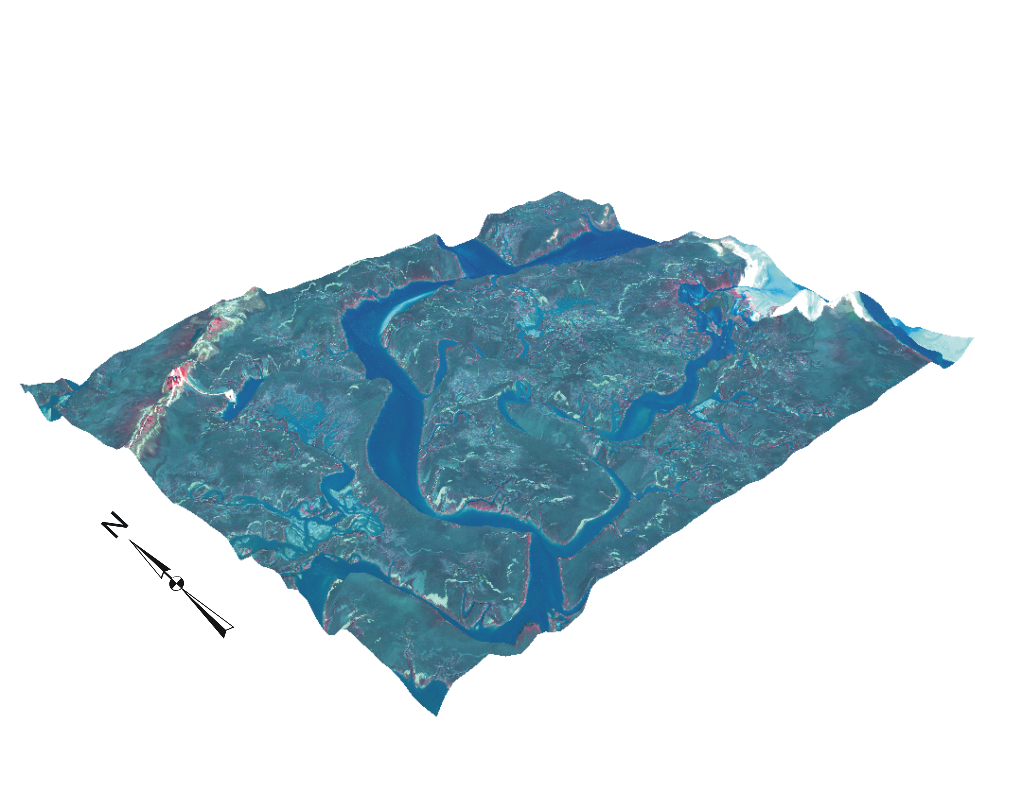
Figure 4. A three-dimensional perspective view of the digital terrain elevation model draped with a false-colour ADAR image. The model covers a ground area of approximately 2180 m by 2760 m. Note that the vertical scale has been exaggerated for 25 times to better portrait the terrain relief.

3. Results and Further Research
The digital elevation model, given its very high spatial resolution and tiny RMSE, allows the differentiation of many delicate terrain features, particularly various micro-landforms and tidal creeks, which can be visualized clearly from Figure 3. These subtle landform features portrayed by the LIDAR-derived DEM are found to be highly faithful to reality when using the high-resolution ADAR image as a reference (see Figure 4). Note that the image color changes in different micro-landform units and where terrain elevation fluctuates.
Further research effort is being made to use this DEM for hydrological network modeling to delineate hydrographical features. This will challenge the existing hydrological modeling technologies which were basically developed for areas with large terrain relief.

Acknowledgments
The author would like to thank James Morris from the University of South Carolina for providing LIDAR and ADAR data and Zhi Liu from the Florida State University for his research assistance.

References
HOBBIE, J.E. (Ed.), 2000, Estuarine Science: A Synthetic Approach to Research and Practice (Washington DC: Island Press). 539p.

HODGSON, M.E., JENSEN, J.R., SCHMIDT, L., SCHILL, S., and DAVIS, B., 2003. An evaluation of LIDAR- and IFSAR-derived digital elevation models in leaf-on conditions with USGS Level 1 and Level 2 DEMs. Remote Sensing of Environment, 84: 295-308.

LOWE, T., 2003. Assessing the Potential of LiDAR/Bathymetry Integration within the Thames Estuary. FIG Working Week 2003, Paris, France, April 13-17, 2003. Http://www.fig.net/pub/fig_2003/TS_20/PP20_2_Lowe.pdf (Last access: 10 May 2007)

MORRIS, J. T., PORTER, D., NEET, M., NOBLE, P.A., SCHMIDT, L., LAPINE. L.A. and JENSEN, J., 2005. Integrating LIDAR elevation data, multispectral imagery, and neural network modeling for marsh characterization. International Journal of Remote Sensing (in print).

NOAA, 2004. North Inlet-Winyah Bay Reserve, South Carolina. Http://nerrs.noaa.gov/NorthInlet/Overview.html (Last access: 10 May 2007)

POPULUS, J., BARREAU, G., FAZILLEAU, J., KERDREUX, M., and L'YAVANC, J., 2001. Assessment of the LIDAR topographic technique over a coastal area. Proceedings of CoastGIS 2001, 18-20 June in Halifax, Canada.

ZEILER, M., 1999. Modeling Our World: The ESRI Guide to Geodatabase Design (Redland: ESRI Press). 199p.

